
PDAN8411
PART 2
Reatlegile Reitumetse Sibanda
ST10229185

Table of Contents
Introduction 2
Research objectives 3
Dataset Selection and Justification 3
Algorithm Selection and Justification 5
Planning requirements 6
Software and libraries 9
Data preparation 9
Exploratory Data Analysis 9
Training and test split 10
Feature selection 11
Model Training 11
Baseline model 12
Hyperparameter tuning 12
Model Evaluation and Comparison 13
Evaluation metrics 13
Baseline results 13
Improved model results 14
Comparison and interpretation 14
Limitations and Further Improvements 18
Conclusion and Recommendations 19
Reference 20

Introduction
Healthcare schemes bear the responsibility of administering benefit applications with procedural expediency whilst concurrently safeguarding that enrolees necessitating appropriate therapeutic interventions remain adequately considered. Pattern recognition algorithms can extract meaningful patterns from retrospective data repositories and generate informational outputs capable of augmenting the decision-making framework.
This study investigates supervised machine learning using the Wisconsin Diagnostic Breast Cancer dataset. The objective is to classify observations as malignant or benign using numerical measurements extracted from digitised images of breast masses.
The research methodology incorporates dataset validation, exploratory data analysis (EDA), data transformation, feature identification, Logistic Regression model construction, evaluation of model performance, and systematic hyperparameter refinement. A comparative examination of the initial and enhanced models is conducted employing classification metrics alongside visual analytical techniques.

Research objectives
The objectives are to:
- Assess the quality and suitability of a cancer-related dataset for binary classification.
- Conduct a thorough examination of the dataset to discern and recognize significant patterns that emerge within the diagnostic classifications.
- Select useful predictive features and train a Logistic Regression classifier.
- Appraise the preliminary model's efficacy through the application of pertinent classification evaluation metrics.
- Investigate whether hyperparameter tuning improves model performance.
- Elucidate the meaning and implications of the observed results, delineate the inherent limitations and delimitations of the present research, and outline recommendations for additional investigation and scholarly advancement.

Dataset Selection and Justification

The Wisconsin Diagnostic Breast Cancer (WDBC) dataset was chosen for this classification investigation due to its pertinence to the medical initiative's aim of examining the potential role of machine learning in facilitating the identification of cancer-related cases. The dataset is accessible via the UCI Machine Learning Repository, an established repository of datasets employed in machine learning and data analysis research. (UCI Machine Learning Repository, n.d.).
This dataset encompasses 569 observations and incorporates 30 numerical predictive features that have been derived from digitized representations of fine needle aspirate samples procured from breast masses. The features delineate the structural and textural attributes of cell nuclei, including but not limited to radius, texture, perimeter, area, smoothness, and concavity. Every observation is labelled with a diagnostic outcome categorizing the specimen as malignant or benign, which establishes the dataset's suitability for supervised binary classification applications.
Data Quality Considerations: This dataset encompasses methodically structured numerical observations paired with unambiguous diagnostic categorizations. The UCI documentation confirms that neither the identified predictive variables nor the diagnostic outcome field exhibit data gaps or omissions. This absence of missing values constitutes an advantageous prerequisite for initiating analytical work. Additionally, the dataset's constrained scale renders it amenable to detailed inspection, visual exploration, and systematic investigation utilizing Python programming tools.
Relevance: The dataset proves suitable for this application because its outcome variable encompasses two mutually exclusive diagnostic classifications, enabling machine learning algorithms to discern distinguishing patterns between malignant and benign manifestations. The continuous numerical attributes contained within the dataset support comprehensive statistical investigation, feature engineering, and model development. Additionally, the dataset affords the opportunity to examine false negative occurrences, which constitute a critical evaluation metric for models developed to assist in the recognition of potentially life-threatening medical conditions.
Constraints: This dataset is narrowly focused on breast cancer and includes diagnostic indicators rather than insurance plan registration, healthcare expenditures, benefit qualification standards, or claims information. Consequently, the model lacks the capacity to determine whether a given individual is eligible for a particular medical scheme benefit. The model's analytical scope is limited to examining the classification of the diagnostic cases contained within the dataset. Moreover, the dataset is comparatively small in magnitude and should not be presumed to be representative of the broader patient population.
Collectively, the WDBC dataset functions as a pertinent and administratively feasible resource for demonstrating exploratory data analysis, feature selection mechanisms, supervised classification frameworks, and approaches to model refinement.

Algorithm Selection and Justification

Logistic Regression was chosen as the predominant classification technique given that the analytical objective entails forecasting between two mutually exclusive diagnostic categories: malignant or benign. Operating as a supervised learning algorithm, it operates by calculating the conditional probability that an observation belongs to a designated class based on the values of its input features.
This algorithmic approach proves suitable for the current research given that the WDBC dataset comprises quantitative measurements serving as explanatory variables. Pre-training feature normalisation enhances the optimisation mechanism, while regularisation strategies diminish overfitting susceptibility by constraining coefficient magnitudes. Additionally, feature selection procedures can be utilised to determine a more parsimonious collection of pertinent predictors.
The interpretability of the algorithm constitutes a supplementary benefit, as the medical scheme necessitates comprehension of the variables contributing to the model's predictive outputs. Nevertheless, the coefficients represent statistical correlations within the estimated model and must not be construed as evidence of causal relationships.
Model performance evaluation will incorporate recall, precision, F1-score, confusion matrix analysis, and ROC-AUC assessment. Heightened focus will be directed toward recall measurements for malignant cases, given that false-negative predictions could lead to the inadvertent neglect of potentially critical cases. While accuracy will be documented and reported, it will not constitute the primary or sole indicator of model success.
The preliminary Logistic Regression model serves as the comparative baseline. Its predictive capacity will subsequently be contrasted with an advanced variant employing strategic feature selection and systematic hyperparameter optimization. The superior model will be identified through performance evaluation conducted on independent test data that was deliberately withheld from both the training phase and the model selection process.

Planning requirements

Stage | Planned actions | Intended outcome
EDA and data cleaning | Conduct a comprehensive examination of dataset characteristics, including dimensional parameters, data type classifications, descriptive statistical measures, absence of values, redundant records, and target variable distribution alongside anomalous observations. Generate visual representations depicting categorical frequencies, univariate feature distributions, inter-variable correlations, and comparative patterns across diagnostic classifications. | Determine data integrity standards and identify critical patterns that emerge from the information.
Feature selection | Distinguish between the independent predictor variables and the dependent diagnosis target. Partition the data into training and testing cohorts using stratified sampling methodology, standardize the predictor variables based solely on training data statistics, and apply a suitable dimensionality-reduction approach including recursive feature elimination (RFE). | Identify beneficial predictive variables while circumventing the inadvertent inclusion of information from the target variable that would artificially inflate model performance.
Train model | Develop a Logistic Regression model utilizing a stratified 80:20 division of the dataset into training and test subsets, with a constant random seed established for consistency. Begin with standard regularization settings, then iteratively refine the regularization coefficient and conditionally adjust class weighting parameters through rigorous cross-validation analysis. | Establish a baseline and an improved classifier.
Evaluate and interpret | Compute the precision, recall, F1-score, accuracy, ROC-AUC metric, and confusion matrix. Analyse false negative instances and juxtapose baseline performance against enhanced results utilizing an identical test dataset. | Evaluate the extent to which the model's performance has advanced and enumerate the outstanding limitations that remain unresolved.
Write report | Provide comprehensive documentation encompassing the dataset description, data cleaning procedures, exploratory data analysis, visual representations, feature selection methodology, model configuration parameters, evaluation outcomes, performance enhancements, identified constraints, and strategic recommendations for future work. | Provide the client with verifiable evidence-based findings and implementable conclusions grounded in rigorous investigation.

The positive class was constituted by malignant presentations. Recall was adopted as the tuning metric of interest, given that the oversight of an authentic malignant presentation constitutes a substantial risk in cancer-related screening-support frameworks. Precision alongside additional performance indicators were maintained to examine the compensatory relationships arising from this strategic selection.

Methodology and Implementation

Software and libraries
Python was used in Jupyter Notebook. Pandas and NumPy supported data handling and numerical operations, while Matplotlib and Seaborn were used for visualisation.
Scikit-learn provided the dataset loader, data-splitting utilities, standardisation, recursive feature elimination, Logistic Regression, cross-validation, hyperparameter tuning and evaluation metrics.
A fixed random seed of 42 was used for reproducibility.

Data preparation
The breast cancer dataset was imported utilizing scikit-learn's load_breast_cancer function, whereby the 30 predictive features were isolated from the associated target variable.
The original target encoding was recalibrated such that malignant cases received a value of 1 and benign cases received a value of 0. This recoding approach enabled uniform assessment of malignant-class precision and recall measurements.
Data-quality validation procedures were implemented to assess the presence of missing values, duplicate records, feature data types, finite numerical values, and zero-variance features. The exploratory data analysis additionally investigated descriptive statistics and potential outlier observations. Anomalous values were preserved rather than summarily excluded, as they may constitute legitimate biological variation.

Exploratory Data Analysis
The dataset encompassed 569 observations, with 357 instances classified as benign and 212 as malignant, representing 62.74% and 37.26% of the total sample, respectively.
Analysis of feature-distribution plots revealed that mean radius, mean perimeter, and mean area exhibited elevated values in malignant cases relative to benign cases. Nevertheless, considerable overlap in these distributions was observed, suggesting that individual measurements alone were insufficient for complete class differentiation.
Boxplot analysis furnished supplementary insights regarding disparities in central tendency, variability, and potential anomalous observations. The correlation heatmap facilitated the examination of associations among predictors and the assessment of potential multicollinearity concerns.

Training and test split
The dataset underwent segmentation into a training fraction of 80% and a testing fraction of 20% utilizing stratified partitioning techniques. This approach maintained the equilibrium of malignant and benign case distributions within each resulting subset.
The training subset contained 455 observations, while the held-out testing subset contained 114 observations.
The testing subset was allocated exclusively for summative evaluation purposes. Standardization procedures and feature selection algorithms were implemented solely during the training phase to minimize the probability of information leakage from the test data.

Feature selection
Recursive feature elimination was used to select 15 features for the baseline model. The method repeatedly fits an estimator and removes less important features until the specified number remains.
The improved model's grid search investigated feature counts of 10, 15, 20 and 25. This allowed the study to examine whether a smaller or larger subset produced better cross-validated recall.
Feature selection was performed within the modelling pipeline rather than on the complete dataset before splitting.

Model Training

Baseline model
The reference model employed standardisation as a preprocessing step, applied recursive feature elimination (RFE) to retain 15 selected features, and utilised logistic regression with an iteration limit of 5,000.
Training was conducted using the training dataset. Following this, both predictions and predicted probabilities were generated for the independent test set.
The baseline model functioned as a control mechanism against which the performance of the enhanced model could be systematically compared.

Hyperparameter tuning
The enhanced model utilized five-fold stratified cross-validation combined with systematic grid search. The hyperparameter exploration investigated:
- Feature set sizes of 10, 15, 20, and 25.
- RFE estimator regularization parameters of 0.1 and 1.0.
- Final classifier regularization parameters of 0.01, 0.1, 1.0, and 10.0.
- Standard and balanced class weighting approaches.
Recall for the malignant class functioned as the primary scoring metric within the grid search framework. Balanced class weighting modulates the relative significance of each class based on their observed frequencies in the training corpus.
The superior configuration identified 20 features, an RFE estimator C value of 0.1, a final classifier C value of 0.1, and balanced class weighting. This optimal configuration demonstrated a mean cross-validated recall of 96.47%.
The cross-validation findings were regarded as a mechanism for model selection, distinct from serving as an estimate of final test-set performance.

Model Evaluation and Comparison

Evaluation metrics
Accuracy denotes the proportion of test observations that are correctly classified by the model. Precision denotes the proportion of cases classified as malignant that were genuinely malignant. Recall denotes the proportion of genuinely malignant cases that the model successfully detected.
The F1-score constitutes the harmonic mean of precision and recall. ROC-AUC assesses the model's effectiveness in ranking malignant observations higher than benign observations across different classification thresholds.
The confusion matrix categorizes true positives, true negatives, false positives, and false negatives. False negatives merit particular emphasis because they represent genuinely malignant cases that were incorrectly classified as benign.

Baseline results
The baseline model achieved the following results:
Metric | Baseline result
Accuracy | 97.37%
Malignant precision | 97.56%
Malignant recall | 95.24%
Malignant F1-score | 96.39%
ROC-AUC | 99.77%

The confusion matrix contained 71 true negatives, one false positive, two false negatives and 40 true positives.
The model therefore correctly classified 111 of the 114 test observations. It identified 40 of the 42 malignant cases, while two actual malignant cases were classified as benign.

Improved model results
The tuned model achieved the following results on the same test set:
Metric | Improved result
Accuracy | 97.37%
Malignant precision | 97.56%
Malignant recall | 95.24%
Malignant F1-score | 96.39%
ROC-AUC | 99.74%

The improved model also produced 71 true negatives, one false positive, two false negatives and 40 true positives.

Comparison and interpretation
The baseline and improved models achieved the same accuracy, precision, recall and F1-score at the default classification threshold. Both correctly classified 111 of the 114 test observations.
The optimized model's ROC-AUC metric demonstrated a minor reduction, decreasing from 99.77% to 99.74%. Therefore, the tuning methodology did not produce improvements in the ultimate test-set classification performance, even though the selected configuration attained a robust mean cross-validated recall of 96.47%.
This difference illustrates why cross-validation and test-set results must be interpreted separately. Cross-validation supports model selection within the training data, whereas the independent test set estimates performance on unseen observations.
These outcomes additionally underscore that accuracy alone proves insufficient as a sole performance indicator. Notwithstanding the achievement of high accuracy by both models, each model overlooked two authentic malignant cases present in the test cohort. In an operational screening-support application, the clinical implications of such misclassifications would demand thorough deliberation.

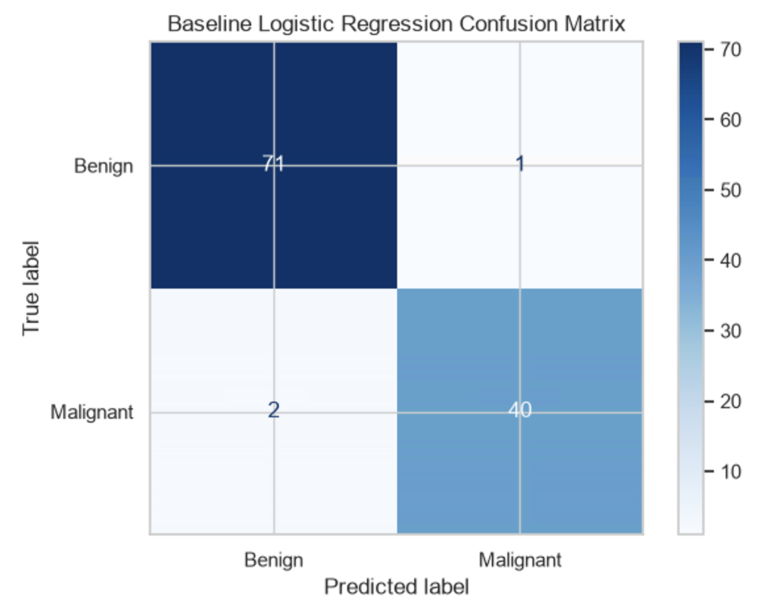

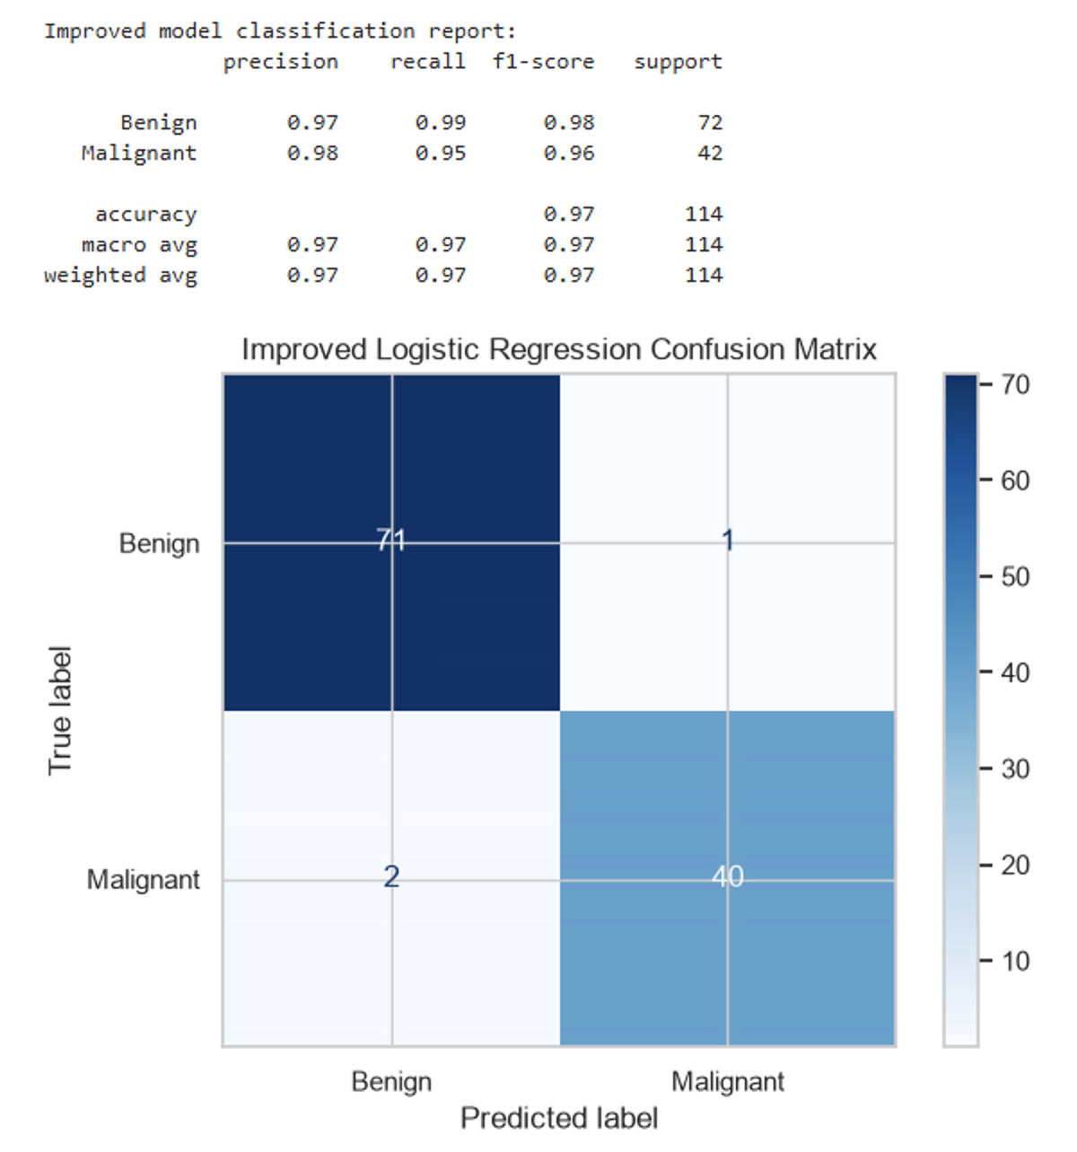

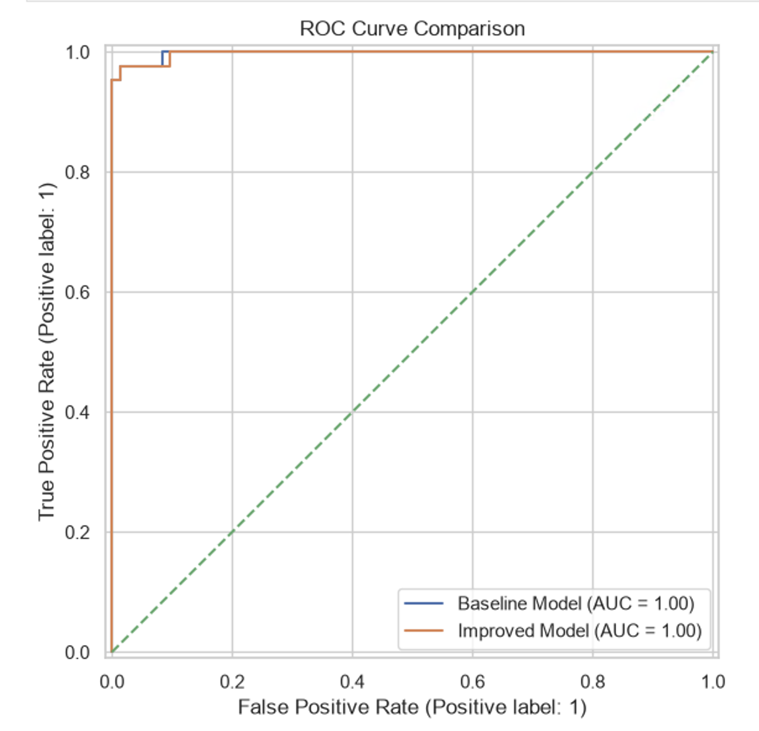

Limitations and Further Improvements

Multiple limitations merit acknowledgment when interpreting these research findings.
First, the dataset comprises merely 569 observations derived from a circumscribed breast cancer diagnostic context. This sample may not adequately represent alternative populations, distinct cancer typologies, or divergent operational medical scheme frameworks.
Second, the test set encompasses only 114 observations, of which 42 constitute malignant cases. Consequently, the reclassification of merely one or two observations can substantially influence the magnitude of reported performance metrics.
Third, the investigation employs a singular train/test partition. Notwithstanding the application of cross-validation for hyperparameter optimization, more robust evidence of generalizability would be established through repeated stratified cross-validation procedures and validation against independent external datasets.
Fourthly, the model excludes treatment expenses, insurance membership details, benefit eligibility criteria, and claims data. Consequently, its predictions cannot establish determinations regarding medical scheme benefit eligibility.
Potential enhancements might encompass examining alternative machine learning algorithms, systematically investigating optimal decision-threshold determination through training-based cross-validation predictions, evaluating probability calibration performance, and analysing precision-recall trade-off dynamics. Subsequent model optimization should preclude repeated selection procedures based on test set outcomes.

Conclusion and Recommendations

This investigation illustrated the utilization of supervised machine learning methodologies applied to the Wisconsin Diagnostic Breast Cancer dataset. Exploratory data analysis revealed substantive distinctions between benign and malignant cases, with notable variations observed in mean radius, mean perimeter, and mean area, thereby justifying subsequent classification-based inquiry.
A baseline Logistic Regression classifier attained 97.37% accuracy, 95.24% malignant-class recall, and 99.77% ROC-AUC across the independent test set. Subsequent hyperparameter tuning identified an optimal configuration utilizing 20 features and balanced class weights; nevertheless, the resulting improved model produced equivalent test-set predictions with a slightly reduced ROC-AUC score of 99.74%.
The findings show that a model can perform well on a particular dataset without necessarily improving after tuning. Model selection must therefore consider multiple metrics, the consequences of false predictions and performance on unseen data.
Moving forward, the medical scheme ought to conduct thorough examinations of appropriately regulated operational information that authentically captures the genuine benefit allocation procedures. Any emerging framework would demand third-party verification, stringent confidentiality measures, impartiality evaluation, and requisite medical and administrative supervision prior to implementation.
The investigation establishes that Logistic Regression constitutes a pertinent foundational instrument for binary cancer classification purposes; nevertheless, expanded verification efforts and specialized empirical datasets would constitute fundamental requirements prior to transitioning toward real-world deployment.

Reference

- UCI Machine Learning Repository (n.d.) [Breast Cancer Wisconsin (Diagnostic)] [online] Available At: https://archive.ics.uci.edu/dataset/17/breast+cancer+wisconsin+diagnostic [Accessed on the 14th of October]

